­­­­Production Model Design Report

F2019 – ECE 298

|  |  |  |  |
| --- | --- | --- | --- |
| Lab Section: | 6 | Group: | 2 |

[For your project, your group will complete one Production Model Design Report. The audience is your manager and the manager of the Production Engineering team, so the document should be of high quality. Inside this report, you will each individually select two issues that must be addressed when bringing a project to production scale (one STEM and one non-STEM issues – choose different topics than your partner). Delete all the instructions in brackets before submitting this document. Use IEEE format to note any relevant references or links [1]. You do this in Word by going to References 🡪 Citations & Bibliography 🡪 Manage Sources to add a source, and then to Insert Citation to use it.]

# Team Members

|  |  |  |
| --- | --- | --- |
| # | Name | Role |
| 1 | Waleed Ahmed | Primary Software Developer |
| 2 | Muhammad Shah | *Primary Hardware Designer* |

# Design Overview

## Problem Statement

Bicyclists sometimes have trouble navigating on roads for obstacles whether it be fellow cyclists, or pedestrians, vehicles on the road. This could be due to several conditions, such a low visibility conditions such as fog or low light hours like dawn or dusk, or perhaps the objects are in a blind spot or the cyclist has simply missed them. In these cases, a warning system is needed to alert the cyclist of objects or people in their vicinity for safety reasons. Design a system that includes two sensors; one front and one rear that can alert the cyclist to the oncoming danger.

## Design Scope

This project solves this problem by having 2 ultrasonic sensors that will be used to find objects at a certain distance from the cyclist. There are two different kinds of indicators that will warn the cyclist for either of their direction; buzzer indicator for forward direction that will have different frequencies depending on the objects distance and level sensitive coloured LED indicators for the rear direction.

It was assumed that the sensors could be mounted onto the front and back of the bicycle at locations where they would be able to safely detect nearby objects without obstructing the bicycle itself and that the sensors would only need to sense objects in the forward and backwards direction. It was also assumed that the cyclist could look at the ultrasonic sensor readings on the LCD at a safe location that wouldn’t cause any distractions for the cyclist.

## Project Design Requirements

1. The project must display the output of the one of the ultrasonic sensor readings, converting the sensor digital readings to a distance value to be displayed on the LCD.
2. The project must turn on a certain coloured LED corresponding to a distance value found from the front sensor value.
3. The project must also create 2 different sounds based upon the distance calculated from the back facing sensor value.
4. The project must also take in push button values that then correspond to setting up and configuring the MCU in either user mode or setup mode and the other push button should be able to set user threshold values.

## System-Level Design (High-Level)

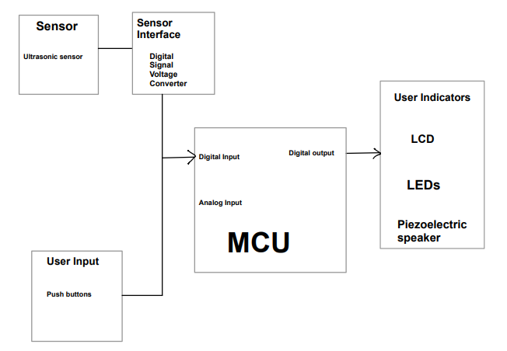

Figure System-Level Design shown with a high -level block diagram

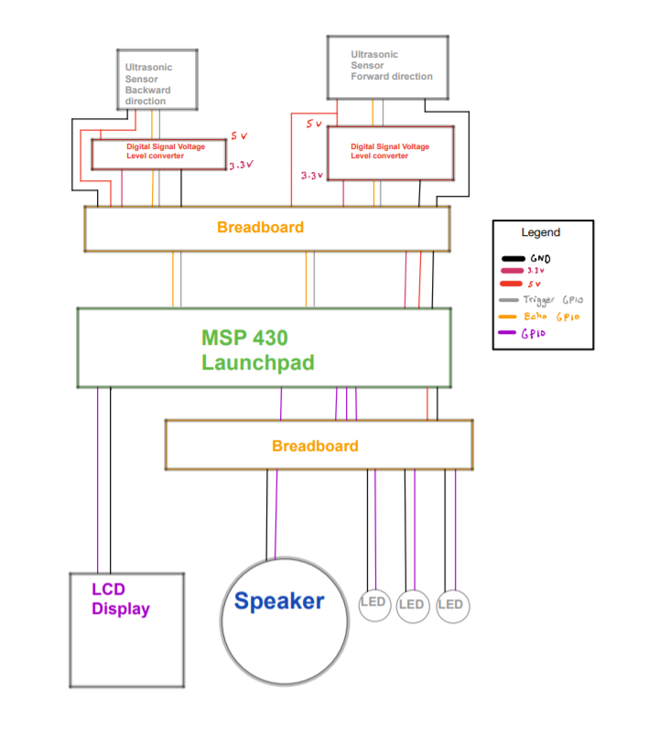

Figure Feasibility Model Diagram

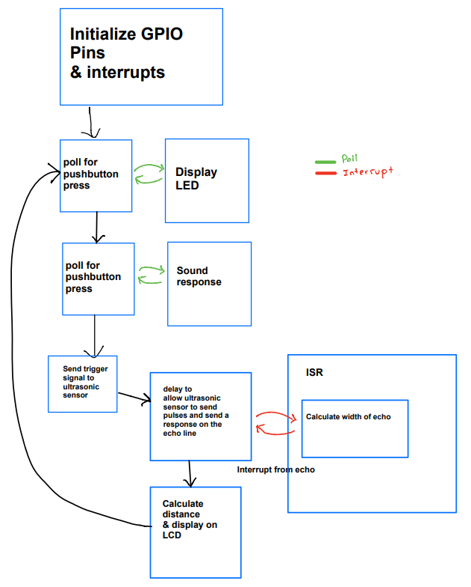

Figure High-Level Software Flowchart

## Completed Prototype

|  |  |  |
| --- | --- | --- |
| Figure Completed prototype with PCB on top of MCU |  | Figure Rear proximity sensor reading for red LED showing object is in the nearest threshold value |
| Figure Rear proximity sensor reading for red Green showing object is in the furthest threshold value |  | Figure Buzzer used for indication that object is near in forward direction |

## Preliminary Production Design Changes

One major issue that needs to be tended to a future revision of the product is to have the product have the correct pin arrangement for the ultrasonic sensor on the PCB. This can be easily be done by fabricating a new PCB design with the correct pin arrangements for the backwards facing ultrasonic sensor.

An enhancement that we could make to our Production Design is that we could add push buttons onto the PCB to allow for easier access for the user. We could also improve our project by using more powerful sensors as the ones we currently use are weak and cannot detect objects that are further away. Another enhancement that we would like to add is to have the sensors be attacked with jumper cables to the PCB so that the PCB can be between the bicycle handles for cyclist and the sensors could be located at appropriate locations on the bike. We would also like to manufacture the board so that it is smaller, so it doesn’t obstruct the cyclist.

# Member 1 Production Details

[Muhammad Shah] – ID# [20725801]

## Design for Reliability

To design the current bicycle sensor project, we would need to make sure that we design the system for reliability. Reliability engineering design describes the system to have the ability to function under a certain condition for a specific period of time for a successful period of time. [2]The reliability of a system and the quality of a system are closely tied. As checking for the quality of a system focuses on minimizing and preventing defects of a product during the warranty phase while on the other hand testing for the reliability of a design is looking to prevent failures during the useful lifetime of the product. The reliability of a system ties closely together with system safety.

Designing for reliability ties very closely into the functionality of our project. As an unreliable bicycle collision detection system is useless, it would be completely unreliable for the user and would cause great harm if it were not reliable as it could result in potential harm to the user if the system cannot detect a nearby object that could cause danger to the user. For example if the user of the project was in a situation where they were in low visibility conditions and they were riding their bicycle fast they would need the help of the sensors to detect objects that are far in front of them so they do not end up going too fast and hitting the object. If the ultrasonic sensors were unreliable in their detection of nearby objects because of an incorrectly designed detection algorithm, software bug, or hardware failure, the buzzer indicator for the forward direction could end up not making a sound for an incoming object and the user might end up hitting an object they did not see. To make sure a scenario like this does not happen to a user of our product we would need to further design our initial prototype to make sure it can perform in a variety of conditions and make sure that it consistently gives correct data.

There are several issues that should remain top-of-mid for the production engineer who will take the prototype design through to a production-ready product. Firstly, the production engineer should take notice of the current ultrasonic sensor we are using. These are the HC-SR04 Ultrasonic Range Finder [1] This is a relatively cheap ultrasonic sensor that has a detection range of 3-400cm but based on testing we found that the max distance to fluctuate at a lower distance of around 50cm to 100cm. This not ideal and it is a suggestion that the production engineer should investigate a more reliable ultrasonic sensor module or perhaps there needs to be further development with the software so that the trigger and echo responses are more accurate. Another issue that the production engineer should regard is that of the PCB layout. Looking at Figure 9 of the PCB layout design the 1x4 J4 connection has a mistake that could be quite an issue for a user. The issue is question is that the pin arrangement is incorrect for the cables, the production engineer team would have to rearrange the pin arrangement for the J4 connector so that they are correct. This can cause an issue in reliability because if the final production model design were to use a 1x4 jumper cable that goes from the J4 connector to the ultrasonic sensor they might end up with incorrect signals going into their ultrasonic sensor and damaging the components. Another issue in reliability that production engineer could tackle is that regarding the method of changing how the ultrasonic sensors are triggered. Looking at Figure 8 one can notice that both the forward and backwards facing ultrasonic sensors are triggered using the same trigger pin and there is no redundancy built in. This could become unreliable in a real-world scenario where the board might receive damage and not trigger correctly anymore. In this case the production team would need to design built in redundancies for triggering if the triggering component fails, and they also might need to investigate creating a design that has 2 sets of triggering mechanisms, 1 for each ultrasonic sensor.

## Ethical Consideration

Engineering ethics is the field of study that focuses on the actions and decisions of a team and group of engineers and the ethics of their actions. [3] Based upon the code of ethics by the PEO. [4] It states “it is the duty of a practitioner to the public, to the practitioner's employer, to the practitioner's clients, to other licensed engineers of the practitioner's profession, and to the practitioner to act at all times with, … 4. devotion to high ideals of personal honour and professional integrity;” as well as several other components. The IEEE also has a code of ethics that its members should follow. [5] The code of ethics is like that of the PEO code of ethics, but some subtle difference and a few more codes involved. These codes of ethics should be key in the decision making for an engineer and their team when working on a project, and the engineer should make sure that they are committing themselves to the highest ethical and professional conduct.

In this project the ethical decisions that we will investigate are regarding the manufacturing of our PCB board, making sure that the project will uphold to being safe to be used by the public by making sure it does not cause injury to those using the product. As stated by the IEEE and PEO code of ethics, engineers should commit themselves to the highest ethical and professional conduct on their work. In the case of our project we must make sure we are not manufacturing our product in a location that violates the code of ethics defined above. We must also perform rigorous testing on our product and make sure it has a reliable design. By testing for reliability, we are ensuring we create an ethical product that works properly, and it does not malfunction and end up injuring the users of our product.

A major ethical issue that we have in regards is in regard to the production of our PCB, we had currently produced our initial PCB prototypes in China, and manufacturing and doing any business in China is known to be a major ethical issue due to their oppressive government, labour rights, stealing of IP and various other issues. [6] [7] I suggest that the team work to try and manufacture the PCB boards either in-house or with a company based in a different location. Another suggestion I make is for the team to provide rigorous testing with the production level design for the project. It is critical that we do as much testing and design changes as we can for this product to make sure it works due to its nature as a safety system. It is in our ethical duty as engineers to make sure that this product does not end up malfunctioning because it could end up disastrous for the user of our product.

# Member 2 Production Details

[Member 2 Name] – ID# [Member 2 ID#]

## [STEM Issue]

[Replace heading with one of these topics: Design for Test (DfT), Design for Manufacturability (DfM), Design for Reliability (DfR), Cables and Connectors, Mechanical Enclosure, Further Integration.]

[Write one paragraph explaining the topic.]

[Write one paragraph explaining how the topic relates to your project.]

[Propose a high-level set of next steps and state any thoughts or issues that should remain top-of-mind for the production engineer who will take your prototype through to a production-ready product. Refer to any codes, standards, or parts that should be noted by the engineer.]

## [Non-STEM Issue]

[Replace heading with one of these topics: Energy Efficiency, Sustainability, Supply Chain Management, Cost Analysis at Volume, RoHS / Environmental Safety, Ethical Considerations, Safety Considerations.]

[Write one paragraph explaining the topic.]

[Write one paragraph explaining how the topic relates to your project.]

[Propose a high-level set of next steps and state any thoughts or issues that should remain top-of-mind for the production engineer who will take your prototype through to a production-ready product. Refer to any codes, standards, or parts that should be noted by the engineer.]

# References

|  |  |
| --- | --- |
| [1] | Robot Shop, "HC-SR04 Ultrasonic Range Finder," 2019. |
| [2] | LCE, "What's the Role of a Reliability Engineer?," LCE, [Online]. Available: https://www.lce.com/Whats-the-role-of-the-Reliability-Engineer-1227.html. [Accessed 30 November 2019]. |
| [3] | A. v. Grop and I. v. d. Poel, "Ethical considerations in engineering design processes.," *IEEE, Technology and Society Magazine,* vol. 20, no. 3, pp. 15-22, 2001. |
| [4] | The Government of Ontario, *Professional Engineers Act, R.S.O. 1990, c. P.28,* Toronto, Ontario, 2018. |
| [5] | IEEE , "IEEE Code of Ethics," 2019. [Online]. Available: https://www.ieee.org/about/corporate/governance/p7-8.html. [Accessed 30 November 2019]. |
| [6] | E. Barret, "Manufacturers Are Considering Leaving China. But It Isn’t All Because of the Trade War," Fortune, 7 June 2019. [Online]. Available: https://fortune.com/2019/06/07/us-china-trade-war-manufacturers-leaving/. [Accessed 30 November 2019]. |

Need to format references

1. <https://www.lce.com/Whats-the-role-of-the-Reliability-Engineer-1227.html>
2. <https://www.robotshop.com/en/hc-sr04-ultrasonic-range-finder-tys.html>
3. <https://www.researchgate.net/publication/3226710_Ethical_considerations_in_engineering_design_processes>
4. <https://www.ontario.ca/laws/regulation/900941>
5. <https://www.ieee.org/about/corporate/governance/p7-8.html>
6. <https://fortune.com/2019/06/07/us-china-trade-war-manufacturers-leaving/>
7. <https://www.theglobeandmail.com/business/adv/article-canadian-companies-eye-new-supply-chains-amid-us-china-trade-war/>

# Appendix – Detailed Design

*[Include design documentation here. The idea is for this document to be a fully detailed snapshot of the prototype. Include the four tables from your Template for Prototype Design document, schematics, layouts, code or a link to a repository, mechanical drawings, etc. I put a Section Break before this part, so you can put the pages landscape if that works better and it won’t affect those pages up front.]*

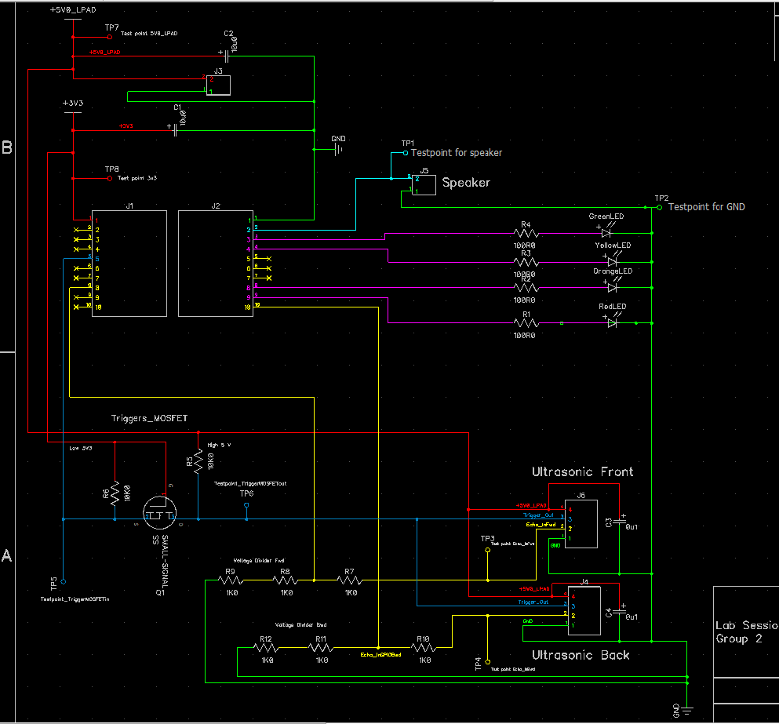

Figure Schematic Diagram

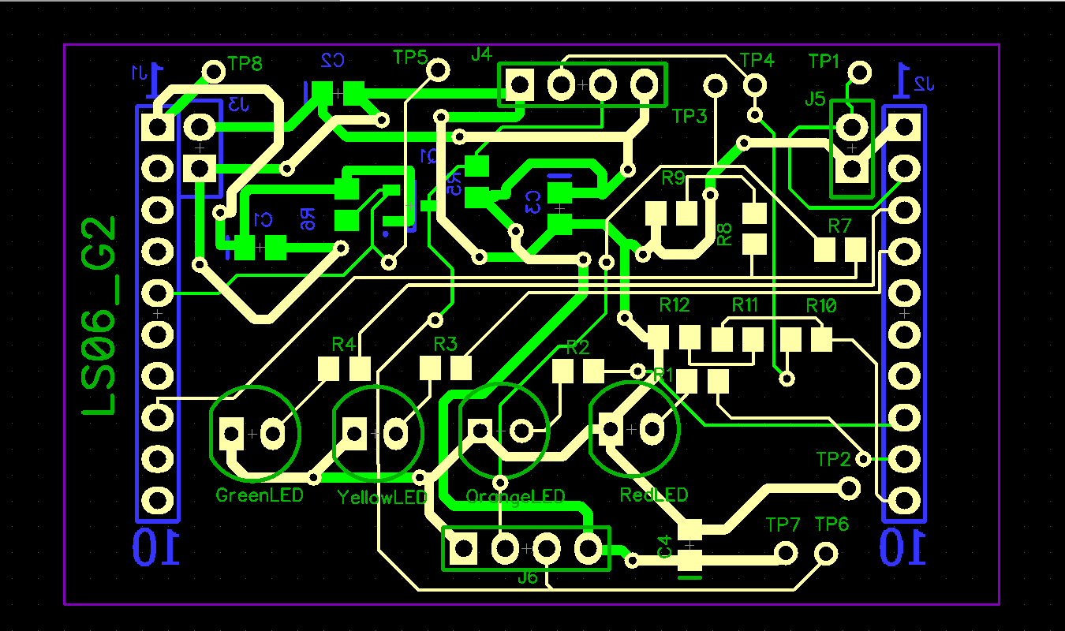

Figure PCB Layout Design